

Travis Vanos

Group 3

GISC9231-D3

**Geo-referencing of Scanned Aerial Imagery and Change Detection**

# Abstract

In this report Equilibrium Consulting will outline the finding of the geo-refernced images as well as analyze the history using remotely sensed data. The following encompasses the data collected from the three aerial image sets (2003 IKONOS Multispectral imagery, 1934-A-set, and 1921 – H set).

Accompanying the 2003 IKONOS aerial imagery are (7) individual images that were geo-referenced to show the progression of the canal's construction and comment on the historical progression of the Welland canal.

Table of Contents

Table of Contents

[Abstract i](#_Toc438001585)

[List of Figures iii](#_Toc438001586)

[1.0 Introduction 1](#_Toc438001587)

[1.2 Background 2](#_Toc438001588)

[1.3 Methodology 4](#_Toc438001589)

[1.3.1 Objectives 4](#_Toc438001590)

[1.3.2 Geo-referencing 5](#_Toc438001591)

[1.4 Findings 5](#_Toc438001592)

[1.4.1 The 1921 Scanned Aerial Images 11](#_Toc438001593)

[1.4.2 IKONOS 2003 Satellite Imagery 12](#_Toc438001594)

[1.7 Conclusion 19](#_Toc438001595)

# 1.0 Introduction

The works have been completed with ESRI’s ArcMap and a collection of aerial images from 2003, 1934 and 1921. The purpose of this assignment is to bring the concepts and methodologies learned in the GISC9231:Remote Sensing to analyze the Historical progression of St. Catharine's Welland Canal. The subsequent findings are then presented in a formal report. The following sections will be fulfilling the deliverables as outlined in the GISC9231-D3.

# 1.2 Background

The Welland canal in its current configuration has seven lift locks and one guard lock, and is crossed by 11 lift-bridges, three tunnels, and one high-level bridge. In an average year approximately 3,400 ships pass through the canal, about 900 of which are oceangoing.

The project to create the original canal was promoted and lobbied for by St Catharines businessman William Hamilton Merritt. Merritt was the son of Loyalists who settled at Twelve Mile Creek in what is now St. Catharines. The project began when he initially wanted to build a feeder canal to run the mills on his family property, but this developed into a far larger project: a ship canal connecting Lakes Erie and Ontario. In 1824, Merritt formed the Welland Canal Company to carry out this ambitious project, and began to raise funds and hire engineers.

The canal has been rebuilt and expanded at least four times since its original configuration/construction. The first canal consisted of 40 wooden locks along an alignment that is west of the current canal (from present day Port Colborne to Port Dalhousie). This first canal was built in two stages, with sections opened in 1829 and 1835. In 1845, a second canal was built that replaced the first. It had 27 stone locks that were larger than the original wooden locks. The third canal was opened in 1887 with 26 stone locks in total. It traversed a route quite different than that of the first and second canals; it progressed east of the original configurations through the existing City of Thorold and then veered north-west through north St. Catharines to Port Dalhousie. The old locks are still visible just south of Glendale Avenue (immediately east of the General Motors plant); however the canal itself is no longer immediately visible in north St. Catharines (although careful examination of aerial photos and maps will show green spaces and road alignments that belay its location). Finally, the fourth canal was opened in 1932. Construction started in 1912, in an alignment similar to the third canal. Instead of proceeding to Port Dalhousie on Lake Ontario, the canal progressed to Port Weller on Lake Ontario. This much straightened alignment progressed through the Ten Mile Creek valley and used a total of 8 concrete locks along its length.

The role for Equilibrium Consulting is to is to examine this history using remotely sensed data by means of is to examine this history using remotely sensed data through means of image interpretation, digital review and change detection etc.

.

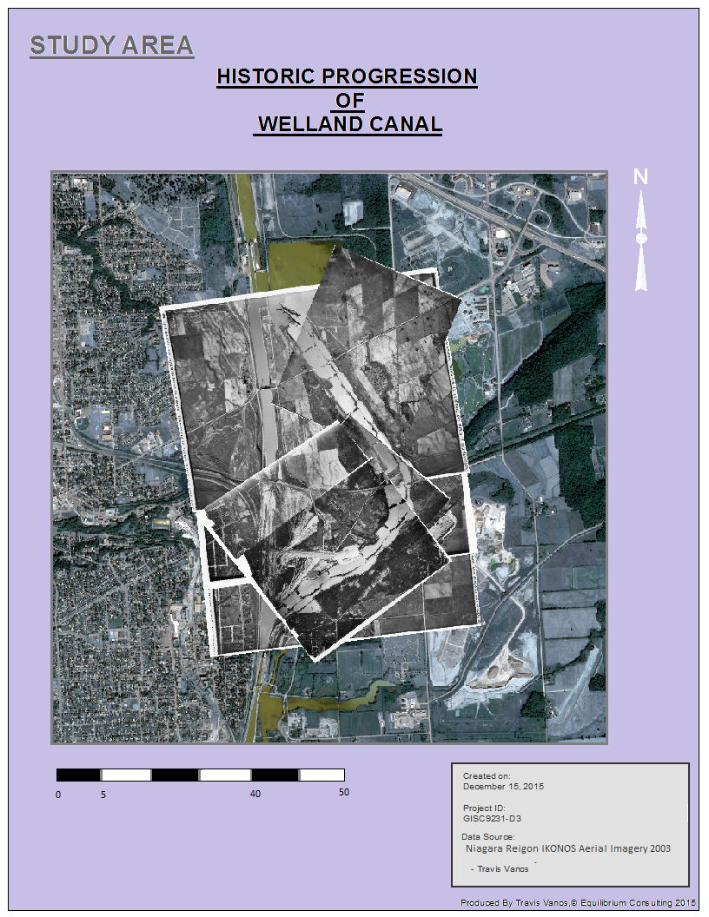

Kilometers

Figure 1 Study Area of Welland Canal

# 1.3 Methodology

## 1.3.1 Objectives

As outlined in the project deliverables, the following (11) objectives have been completed in ESRI’s ArcGIS Suite. The objectives below have been summarized as major tasks in each objective.

|  |  |
| --- | --- |
| ***Objective #1*** | **What was the operational status of each of the canals in 1934? Why do you draw this conclusion?** |
| ***Objective #2*** | **Referring to** [**A4873-20 Welland Canals 1934 (JPEG)**](http://blackboard.niagarac.on.ca/courses/1/GISC9231-GC01-FA-PS/content/_45276_1/1934_Features.jpg)**, what is the wedge shaped formation at location A? What are the striations?** |
| ***Objective #3*** | **Again, referring to** [**A4873-20 Welland Canals 1934 (JPEG)**](http://blackboard.niagarac.on.ca/courses/1/GISC9231-GC01-FA-PS/content/_45276_1/1934_Features.jpg)**, what is the linear feature at location B? What was its status in 1934 (was it actively being used)? What is your evidence?** |
| ***Objective #4*** | **Again, referring to** [**A4873-20 Welland Canals 1934 (JPEG)**](http://blackboard.niagarac.on.ca/courses/1/GISC9231-GC01-FA-PS/content/_45276_1/1934_Features.jpg)**, why do you suppose the pond at C existed? Support your hypothesis thoroughly.** |
| ***Objective #5*** | **Again, referring to** [**A4873-20 Welland Canals 1934 (JPEG)**](http://blackboard.niagarac.on.ca/courses/1/GISC9231-GC01-FA-PS/content/_45276_1/1934_Features.jpg)**, what is area E? Justify your hypothesis.** |
| ***Objective #6*** | **What was the operational status of each of the canals in 1921? Why do you draw this conclusion?** |
| ***Objective #7*** | **What was the operational status of each of the canals in 2003? Why do you draw this conclusion?** |
| ***Objective #8*** | **Figure 1 above as well as** [**H22-25 Welland Canal Locks 1921 (JPEG)**](http://blackboard.niagarac.on.ca/courses/1/GISC9231-GC01-FA-PS/content/_45279_1/Locks_12_to_15_in_1921.jpg) **and** [**H22-91 Welland Canal Locks 1921 (JPEG)**](http://blackboard.niagarac.on.ca/courses/1/GISC9231-GC01-FA-PS/content/_45280_1/Locks_16_to_21_in_1921.jpg) **show the lock numbering system in 1921 for the 3rd canal. Create a table that shows how locks 11 through 24 are/are-not visible to our remote sensing platforms in 1934 and 2003. For each year, note whether the lock is visible, Visible - partially , not visible or not shown on the imagery. For non-visible locks, add a comment column to your table detailing why the lock is no longer visible.** |
| ***Objective #9*** | **Describe the changes within the lands of the Fuller Plan from 1921 through 1934 to 2003. Speculate why these changes occurred.** |
| ***Objective #10*** | **What happened to the wedge shaped landform at location A of to** [**A4873-20 Welland Canals 1934 (JPEG)**](http://blackboard.niagarac.on.ca/courses/1/GISC9231-GC01-FA-PS/content/_45276_1/1934_Features.jpg) **that was visible in 1921 and 1934? Support your hypothesis.** |
| ***Objective #11*** | **Create two figures for your report that show (via screen save or formal ArcGIS layout) the geo-referened imagery overlaid atop the IKONOS satellite image. One Figure for the 1921 imagery and one for the 1934 imagery.** |

## 1.3.2 Geo-referencing

To geo-reference something means to define its existence in physical space. That is, establishing its location in terms of map projections or coordinate systems. The digital .tiff images have been given to analyze changes in three years: 1921, 1934, and 2003. Using the geo-referencing tools the ArcGIS were then used to reference specific points of the historical images to overlay them on the, more modern, IKONOS aerial imagery.

Using these tools in ArcGIS, ‘control points’ are then located in an unprocessed image and connect it with the same ‘control points’ in already geo-referenced image. As more points are involved, the accuracy increases. In addition the Swipe Layer in Effects Toolbar allows for comparison of one image to another .

# 1.4 Findings

1. **What was the operational status of each of the canals in 1934? Why do you draw this conclusion?**

After observing the canal in the 1934 images, one can see the locks/ canal portion are no longer operational in 1934. Partly dried chambers and an abundance of overgrown growing in/around locks as seen in Figure 2.

E:\Учеба\GIS\GISC9231 - Remote Sensing\3rd Assignment\Assignment #3\A4873_19.tif

Figure 2: Canal portion - 1934.

By observing the long shadows in the locks, it is clear that there is no water as well as in the reservoir which used to regulate the water level in the locks.

The fourth canal was still operational in 1934. Figure 3 shows that it had straight lines, and filled with water, gates closed. The bridges that cross the canal were already built and appear operational.

E:\Учеба\GIS\GISC9231 - Remote Sensing\3rd Assignment\Assignment #3\A4873_19.tif

Figure 3: The 4thCanal portion - 1934.

Thus, the fourth canal was operational in 1934, and the third canal was condemned.

1. **Referring to** [**A4873-20 Welland Canals 1934 (JPEG)**](http://blackboard.niagarac.on.ca/courses/1/GISC9231-GC01-FA-PS/content/_45276_1/1934_Features.jpg)**, what is the wedge shaped formation at location A? What are the striations?**

This formation is situated between the fourth and the third canal. The feature is located adjacent to railroad and crossed by several roads or pathways. The formation has an unusual wedgd shape. There are conical striations which is the evidence of construction activity. Also, by shadow One can speculate that that the formation is not flat and has an elevation. The northern part of the feature is of higher elevation.

**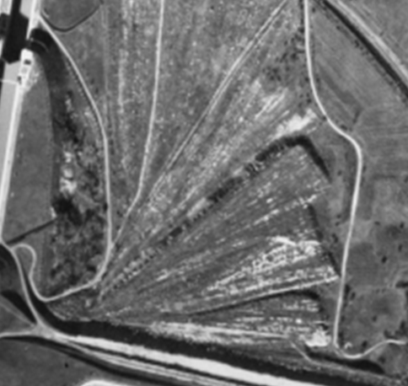**

Figure 4 Formations at Location A.

1. **Again, referring to** [**A4873-20 Welland Canals 1934 (JPEG)**](http://blackboard.niagarac.on.ca/courses/1/GISC9231-GC01-FA-PS/content/_45276_1/1934_Features.jpg)**, what is the linear feature at location B? What was its status in 1934 (was it actively being used)? What is your evidence?**

At location B one can observe railroad tracks leading into the Blue Ghost tunnel (Merriton tunnel). The status of the Blue Ghost Tunnel in 1934 was officially closed, the tunnel was closed in 1915. The tracks appears to be of different elevation and with a buffer for a ditch, which is different from the surrounding features as the tunnel goes under the canal. The shadow that covers the track as it edges closer to the tunnel. As presented in the assignment Terms of Reference, the track would be not operational at this time.

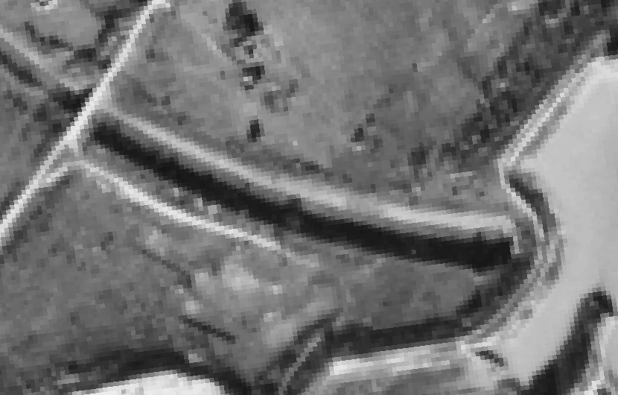

Figure 6 Tracks leading to "Ghost Tunnel"

**d) Again, referring to** [**A4873-20 Welland Canals 1934 (JPEG)**](http://blackboard.niagarac.on.ca/courses/1/GISC9231-GC01-FA-PS/content/_45276_1/1934_Features.jpg)**, why do you suppose the pond at C existed? Support your hypothesis thoroughly.**

The pond located at location C, which is situated between the canals formed in between the period of the 1921 and 1934 aerial images. The pond may have been caused by the drainage or some leakage of the locks when they were operational. However, it is likely they formed as a result of the construction on the canal in the area. With the way the striations are formed, it appears to be filling in the pond and the area with the natural water flow.

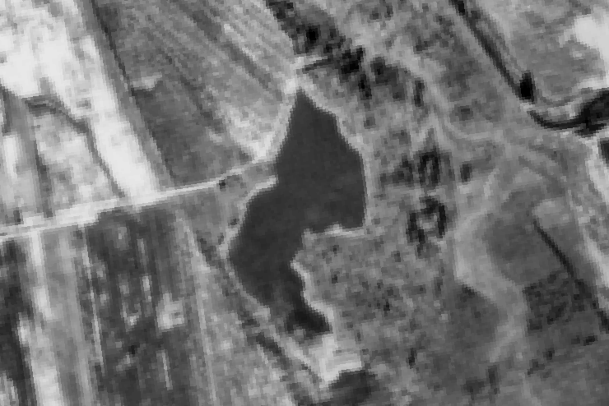

Figure 7 Pond between canals

**E) Again, referring to** [**A4873-20 Welland Canals 1934 (JPEG)**](http://blackboard.niagarac.on.ca/courses/1/GISC9231-GC01-FA-PS/content/_45276_1/1934_Features.jpg)**, what is area E? Justify your hypothesis.**

Again, referring to Orthoscopic image A4873, Welland Canals 1934, it appears to be agricultural fields in the middle of the two canals. This is theorized as the fields are divided similar to how other agricultural fields are and look. The colours and linear patterns associated with the field also indicate that it was used for agricultural. The fields look unsown and this may be a result of the canal construction. In the later IKONOS Multispectral Imagery, the land use change is apparent as there is a large factory were these fields sat.

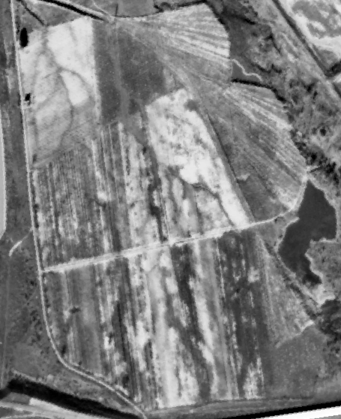

Figure 8 Agriculture in between the canals

## 1.4.1 The 1921 Scanned Aerial Images

**F) What was the operational status of each of the canals in 1921? Why do you draw this conclusion?**

At the time the aerial photos the fourth canal was currently under construction at the time of this photo, thus making the canal un-operational. The canal was completed in 1932, therefore it making it impossible to be partially operational. Water cannot be seen by the tone we woud expect to see in the Orthosopic. The tones do not represent water within the canal path, but the tones show construction activity.

The third canal, however, appears operational due to the obvious presence of water in the lock systems.

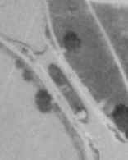

Figure 9 Ship stationary in lock 12

## 1.4.2 IKONOS 2003 Satellite Imagery

**G) What was the operational status of each of the canals in 2003? Why do you draw this conclusion?**

The construction of the 4th canal was completed and in the 2003 IKONOS imagery shows the present day Welland Lock system. A reassuring sign is the two ships passing through the canal at the time of this photo as seen in Figure 10 . The third canal is no longer in use as the new systm has been upgraded and is used solely. This is known as a result of the overgrown sections and land use change of the third canal. Figure 10 is a photo of lock 13, 14 and 15 on the 3rd canal in 1921, while figure 11 is a photo of the exact same area, but in 2003. The abandoned 3rd canal appears to be straightened, while the water bodies have disappeared as roads had been built. As a result of these changes the canal appears to be impassable as the locks are not operational anymore.

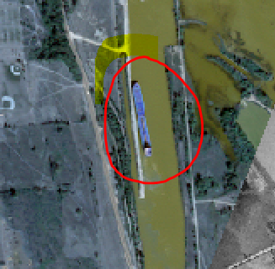

Figure 10 Ship in lock system

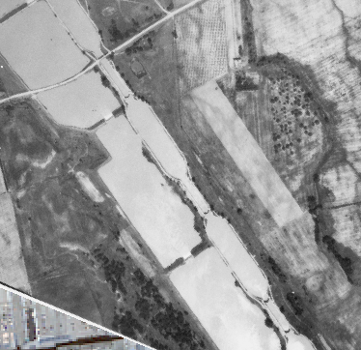

Figure 11 Historic 3rd Canal

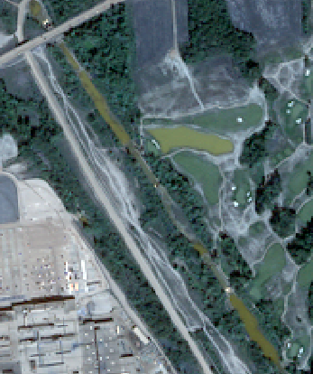

Figure 12 3rd canal as seen in IKONOS 2003 Orthoimagery

**H) Figure 1 above as well as** [**H22-25 Welland Canal Locks 1921 (JPEG)**](http://blackboard.niagarac.on.ca/courses/1/GISC9231-GC01-FA-PS/content/_45279_1/Locks_12_to_15_in_1921.jpg) **and** [**H22-91 Welland Canal Locks 1921 (JPEG)**](http://blackboard.niagarac.on.ca/courses/1/GISC9231-GC01-FA-PS/content/_45280_1/Locks_16_to_21_in_1921.jpg) **show the lock numbering system in 1921 for the 3rd canal. Create a table that shows how locks 11 through 24 are/are-not visible to our remote sensing platforms in 1934 and 2003. For each year, note whether the lock is visible, Visible - partially , not visible or not shown on the imagery. For non-visible locks, add a comment column to your table detailing why the lock is no longer visible.**

|  |  |  |  |  |  |
| --- | --- | --- | --- | --- | --- |
| **Number of Lock** | **1934 Image** | **Comments** |  | **2003 Image** | **Comments** |
| 11 | Visible - clearly | In poor condition. |  | Visible - partially | In poor condition, overgrown, abandoned lock, flooded |
| 12 | Visible - clearly | In poor condition but distinguishable. Area around the lock was partially submerged |  | Visible - partially | In poor condition, overgrown, abandoned lock, flooded |
| 13 | Visible - clearly | In poor condition but distinguishable |  | Visible - partially | In poor condition, overgrown, abandoned lock, flooded |
| 14 | Visible - clearly | In poor condition but distinguishable |  | Visible - partially | In poor condition, overgrown, abandoned lock, flooded |
| 15 | Visible - clearly | In poor condition but distinguishable |  | Visible - partially | In poor condition, overgrown, abandoned lock, flooded |
| 16 | Visible - clearly | In poor condition but distinguishable |  | Visible - partially | In poor condition, overgrown, abandoned lock, flooded |
| 17 | Visible - clearly | In poor condition but distinguishable |  | Visible - partially | In poor condition, overgrown, abandoned lock, flooded |
| 18 | Visible - clearly | In poor condition but distinguishable |  | Visible - partially | In poor condition, overgrown, abandoned lock, flooded |
| 19 | Visible - partially | Only northern part of lock is Visible - clearly. Lock has been rebuilt and changed its direction from south west to south. |  | Not Visible - clearly | Lock has been rebuilt. Lock is hidden by overgrown. |
| 20 | Not Visible | Submerged due to 4 canal construction |  | Not Visible | Submerged due to 4 canal construction |
| 21 | Visible - partially | Partially submerged, overgrown, In poor condition, abandoned lock |  | Visible - partially | Partially submerged, overgrown, In poor condition, abandoned lock |
| 22 | Visible - partially | No longer operational, overgrown, In poor condition, abandoned lock |  | Visible - partially | No longer operational, overgrown, In poor condition, abandoned lock |
| 23 | Not shown | Out of image bounds |  | Not Visible | No longer exists due to canal completion |
| 24 | Not shown | Out of image bounds |  | Not Visible | No longer exists due to canal completion |

**I) Describe the changes within the lands of the Fuller Plan from 1921 through 1934 to 2003. Speculate why these changes occurred.**

The lands currently are contain a railroad (C.N) and two roads. As referenced in the history, the Reverend Thomas Fuller had plans to use the land for housing. As seen in figure 13 within Fuller's area there are large sections of only agricultural land with no man made POI''s. Agriculture continued to be its primary source.

**K) Create two figures for your report that show (via screen save or formal ArcGIS layout) the geo-referened imagery overlaid atop the IKONOS satellite image. One Figure for the 1921 imagery and one for the 1934 imagery.**

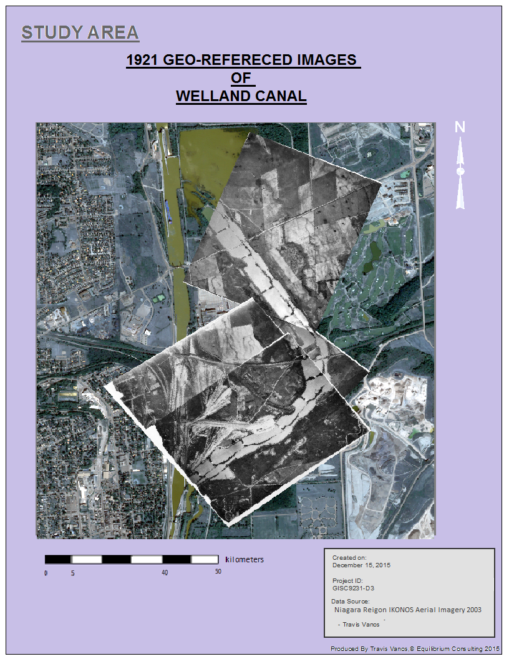

Figure 13 1921 GEO-REFERENCED IMAGES OF WELLAND CANAL

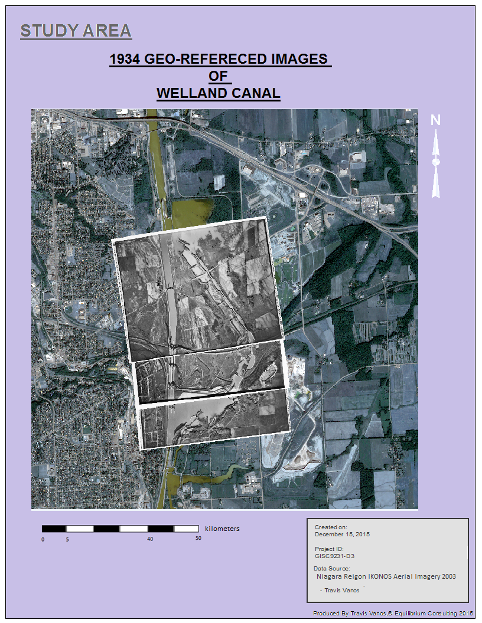

Figure 14 1934 GEO-REFERENCED IMAGES OF WELLAND CANAL

# 1.7 Conclusion

The findings have been presented by Equilibrium Consulting for the speculations of the Welland Canal area. The purpose of this assignment is to bring the concepts and methodologies learned in the GISC9231:Remote Sensing to analyze the Historical progression of St. Catharine's Welland Canal . Along with the historical resources we have a clear understanding of the progression the lands undertook by means of historically geo-referenced Ortho images and and change detection.